DAY 5-8-2025

LOOPS AND ITERATION **1. Write a program to print numbers from 1 to 100.**

**IPO:**

Input: -

Process: use for loop Output: Numbers from 1 to 100

**CODE:**

#include <stdio.h> void main()

{ for(int i = 1; i <= 100; i++)

{ printf("%d ", i);

}

}

**OUTPUT:**



**print even numbers from 1 to 50.**

-

Process: use for loop and if condition Output: Even numbers from 1 to 50

**CODE:**

#include <stdio.h> void main()

{ for(int i = 1; i <= 50; i++)

{ if(i % 2 == 0) printf("%d ", i);

}

}

**OUTPUT:**



**find the factorial of a number.**

Assing a number

Multiply numbers from 1 to n Output: Factorial of n

**CODE:**

#include <stdio.h> void main()

{

int number, fact = 1; scanf("%d", & number); for(int i = 1; i <= number; i++)

{ fact *= i;

}

printf("Factorial = %d", fact);

}

**OUTPUT:**

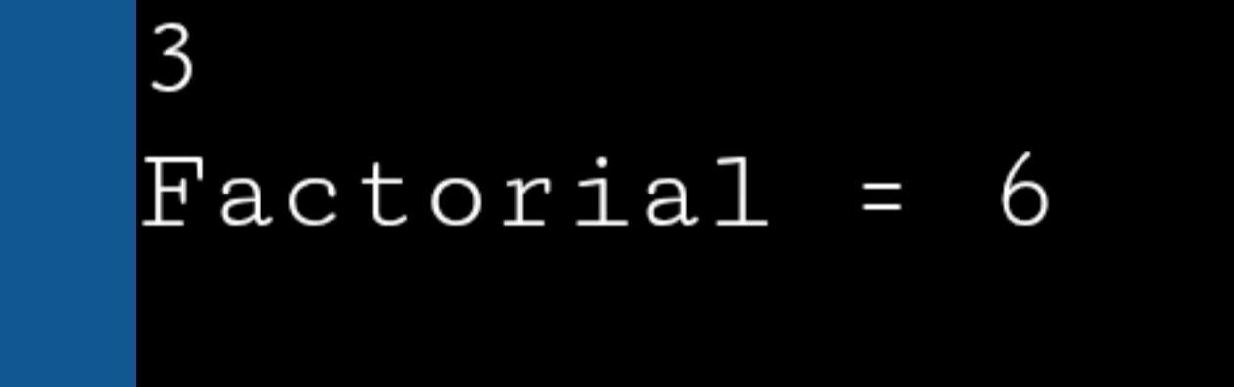

**calculate the sum of digits of a number.**

Enter a Number

Extract digits and sum Output: Sum of digits

**CODE:**

#include <stdio.h> void main()

{

int num, sum = 0; scanf("%d", &num); while(num != 0)

{

sum += num % 10; num /= 10;

}

printf("Sum = %d", sum);

}

**OUTPUT:**

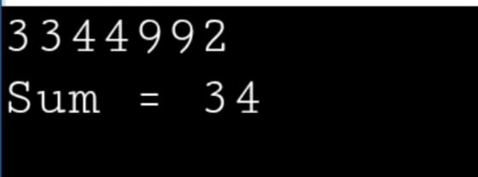

**reverse a number.**

Enter a Number

Extract digits and reverse Output: Reversed number

**CODE:**

#include <stdio.h> void main()

{

int num, rev = 0; scanf("%d", &num); while(num != 0)

{

rev = rev * 10 + num % 10; num /= 10;

}

printf("Reversed = %d", rev);

}

**OUTPUT:**

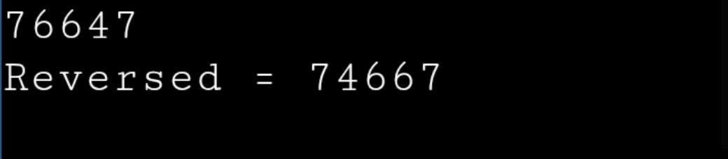

**6. Write a program to check whether a number is a palindrome**

**IPO:**

Input:Enter a Number

Process: Reverse and compare with original

Output: Palindrome or not

**CODE:**

#include <stdio.h> void main()

{

int num, temp, rev = 0; scanf("%d", &num); temp = num; while(num != 0)

{

rev = rev * 10 + num % 10; num /= 10;

}

if(temp == rev) printf(" It is Palindrome"); else printf("It is Not Palindrome");

}

**OUTPUT:**

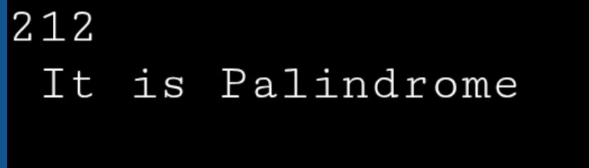

**7. Write a program to print multiplication table of a number.**

**IPO:**

Input: Enter a Number

Process: Multiply by 1 to 10

Output: Multiplication table

**CODE:**

#include <stdio.h> void main()

{ int n;

scanf("%d", &n); for(int i = 1; i <= 10; i++)

{ printf("%d x %d = %d\n", n, i, n * i);

}

}

**OUTPUT:**

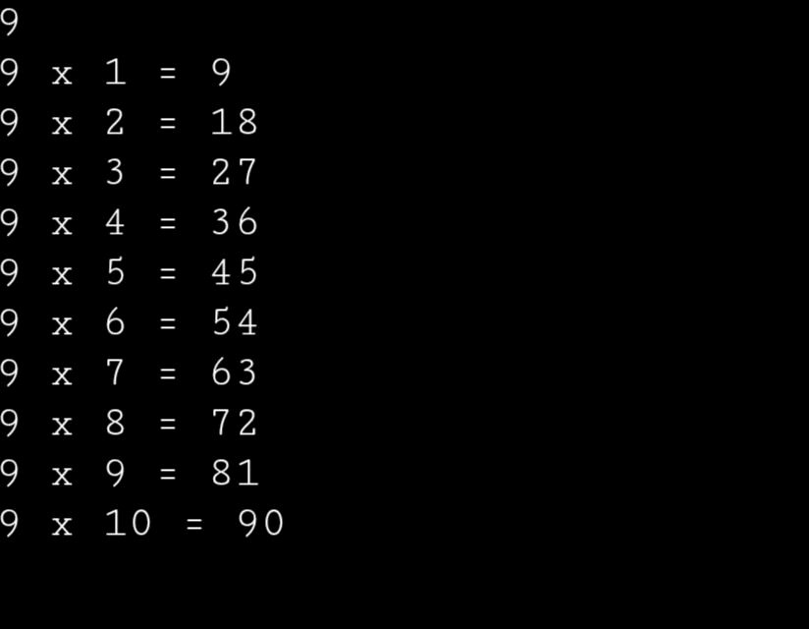

**8. Write a program to count the number of digits in a number.**

**IPO:**

Input: Enter a Number

Process: Divide by 10 and count

Output: Total digits

**CODE:**

#include <stdio.h> void main()

{

int num, count = 0; scanf("%d", &num); while(num != 0)

{ num /= 10; count++;

}

printf("Digits = %d", count);

}

**OUTPUT:**

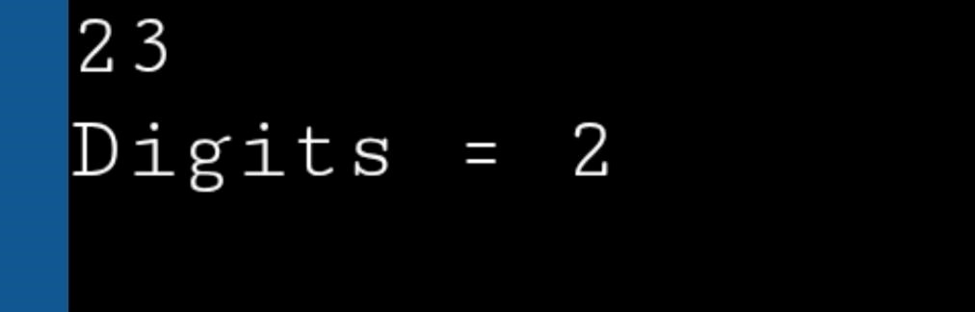

**9. Write a program to print the Fibonacci series up to n terms.**

**IPO:**

Input: Enter a Number

Process: Generate Fibonacci series

Output: Fibonacci series up to n

**CODE:**

#include <stdio.h> void main()

{ int n, a = 0, b = 1, c; scanf("%d", &n); printf("%d %d ", a, b); for(int i = 3; i <= n; i++)

{ c = a + b; printf("%d ", c); a = b; b = c;

}

}

**OUTPUT:**

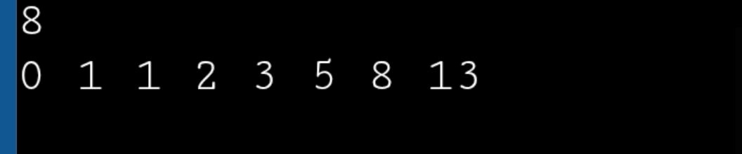

**10. Write a program to calculate the sum of the first n natural numbers**

**IPO:**

Input: Enter a Number

Process: Sum 1 to n using formula Output: Sum of n natural numbers

**CODE:**

#include <stdio.h> void main()

{

int n, sum; scanf("%d", &n); sum = n * (n + 1) / 2; printf("Sum = %d", sum);

}

**OUTPUT:**

